Practice 3 JavaScript
Q1. Instruction on how to start.
- Open Visual Studio Code.
- Install extension: Code Runner
- Open a folder to keep all your JavaScript 1 Practice source code.
- For question 1, create a new Q1 folder. Inside the folder, create a new file Q1.js
- You may write your JavaScript code directly in the file and run. For example:
File: Q1.js
console.log("hello world");

function dbg(m){
console.log("debug: " + m);
}

dbg("hello world");

See the instruction below:

You will find the console.log output in OUTPUT tab (as highlighted above).

Q2. You will learn how to return multiple values in function.
- Create a function with 3 input parameters of type numbers.
- Increment the 3 inputs by 1 and return 3 new values.
One easy way to return the multiple values is to use array (Some hints…the following is not the running code).
f(a, b, c) {
// logic
return [d, e, f]; // very import clue
}
const [x, y, z] = f(1, 2, 3); // very import clue

Check the values of x, y, and z to see if it is what you expect (like use console.log). Test your function:
Function input | Function output
f(-1, -1, -1) | 0, 0, 0
f(99, 49, 19) | 100, 50, 20
f(100, 200, 300) | 101, 201, 301

Q3. Create a swap function with 2 inputs.
- If the first input value is larger than the second variable, swap the 2 values and return the swapped values.
- If the first input value is smaller than the second value, return the 2 values without swapping them.
- You function return 2 outputs.
Use the knowledge you have learnt from question 2. Output (e.g. console.log) the values after you have call swap function. Test you function with the following input:
swap(67, 80) returns 67, 80
swap(80, 67) returns 67, 80
swap(-5, -6) returns -6, -5
swap(-6, -5) returns -6, -5

Q4. Given the following number array:
scores = [67, 80, 56, 95, 80, 75, 75, 92, 91, 77];
Our objective is to sort the array in ascending order. The following pseudo code describe how to do the swap (you can find other sorting algorithm pseudo code from the Internet)
A simple sorting algorithm (actually, it is called bubble sort)
For loop 10 times (we call outer loop): i = 0 to 9
For loop 9 times (inner loop): j = 0 to 8
a = scores[j]
b = scores[j + 1]
swap(a, b)
scores[j] = a
scores[j + 1] = b
Output the array before and after you do the sorting.
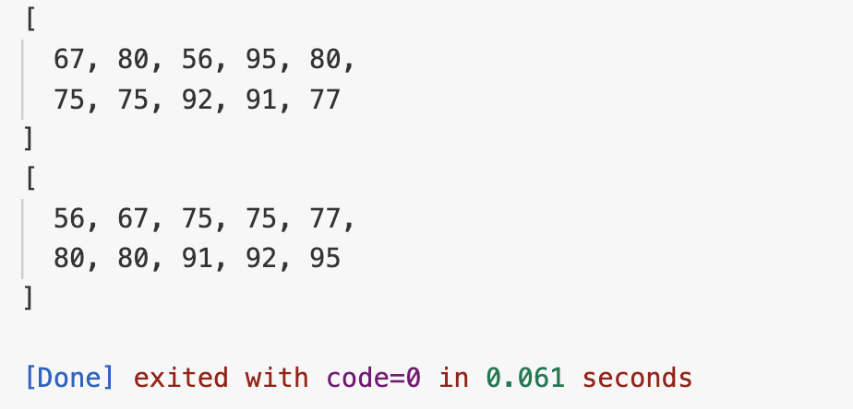
Q5. Continue from question 4. Turn your algorithm into a function, input is an unsorted array. This sorting function is sorting array in ascending order.
- Replace your hardcoded loop numbers (9 and 8) with scores.length.
- Add/remove numbers or change the array and try again
Reflection for you (you may share with your course lecturer):
- What do you learn from this practice?
- How did question 2 and 3 help you?
- What if you start with question 4 without 2 & 3, will you be lost?
- There are built-in functions to sort an array, object, string. How do you think they are built?

Q6. (Optional) Built another algorithm that sort string in descending order.

Q7. Your task is to define two new functions:
- A function called subtract which takes two numbers as inputs and returns the difference.
- A second function, called stringify, which takes a number as an input and returns a string that includes the number (e.g., "Result: 10" for the input 10).
The first function (subtract) should be callable like this:
subtract(12, 10);

and then return 2 (for this example, where 12 and 10 are passed as values).
The second function (stringify) should be callable like this:
stringify(10);

and then return a string that includes the number - for example "Result: 10".

Q8. Read and writing of files.
Part A: Write to file
- You can refer to this URL: https://nodejs.org/en/learn/manipulating-files/writing-files-with-nodejs
- Use fs.writeFile function in the first example.
- The parameters for fs.writeFile(A, B, C) where:
A: path or location of the file. Use “./myfile.txt”
B: the data you want to write to file. Try “Hello World”
C: callback function with 1 parameter. This parameter is err or error. If the write file operation fails, err will content the error message. If write operation is successful, if(err) will be false. To keep consistency, this callback function should be declared in this manner: (err) =>
fs.writeFile(…, (err) => {
// your logic
…
When you run the code, you will find a new file name “myfile.txt” getting create. Where this file is located, depends on where the command is ran. For example, this is not in the source code fold but one hierarchy above:
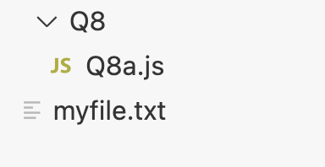

Part B: Reading a file
- You can refer to this URL: https://nodejs.org/en/learn/manipulating-files/reading-files-with-nodejs
- Use fs.readFileSync function in the second example.
- Read the content of the file you write in part A.
- The parameters for fs.readFileSync(A, B) where:
A: path or location of the file. Use “./myfile.txt”
B: keep the type to “utf8”
Return: This function return the file content
Output the content of the file in console. Try to change the content in part A and see if you can get the correct output?

Part C: Read a CSV file (provide to you)
Use what you have learnt in Part B to read the CSV content. The entire CVS will be read into the data variable (take Part B as example). CSV uses comma to separate the data and each row end with a newline (\n) character.
Row1_data,Row1_data,Row1_data(newline character - invisible)
Row2_data,Row2_data,…
To extract the cell data (e.g. Row1_data), you will need to:
- Read row by row
- For each row, extract each column
- The column will yield Row1_data
How to split?
Using <string>.split() function (reference: https://www.w3schools.com/jsref/jsref_split.asp ). We look at a sample code to split the data line by line:
const data = fs.readFile("data.csv");
const lines = data.split("\n");
console.log(lines[0]); // Output header row

As mentioned, each row ended with an invisible newline character (\n). So, this is the symbol split function look for. The function returned an array. This code will output the first line (Rank,Movie,Release Date,Gross) to the console.
Then, you will need to iterate row by row (thus, “Read row by row”). There are a few ways to iterate, here are some examples:
Using for loop and array length to iterate rows
const data = fs.readFileSync("data.csv", "utf-8");
const lines = data.split("\n"); // 4 rows in array
for(let i = 0; i < lines.length; i++){
console.log(lines[i]); // Output row by row
}

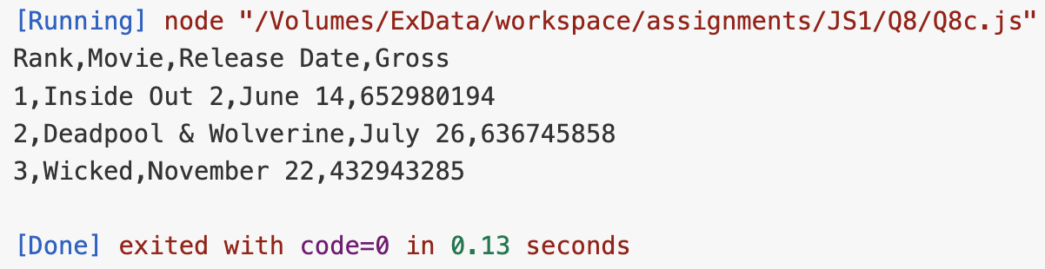

Snippet of using for…of to get each column in header row
const data = fs.readFileSync("data.csv", "utf-8");
const lines = data.split("\n");
const columns = lines[0].split(",");
for (const column of columns) {
console.log(column);
}

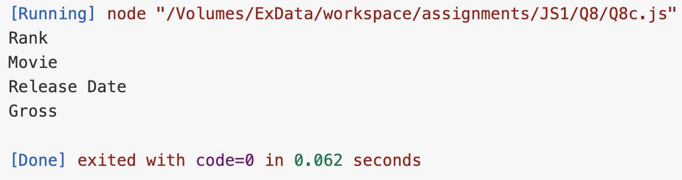
With this knowledge, create the output as shown below.
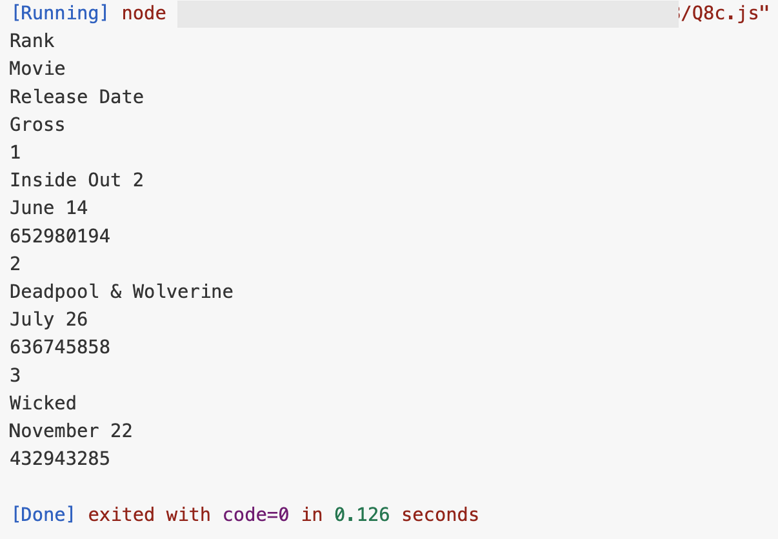

Part D: Create JavaScript object with CSV data.
Use the following object structure and your solution in Part C, create a JavaScript Object. Use JavaScript to code a program to do this. Avoid hardcode the data.
boxOfficeData :
[
{Rank: '1', Movie: 'Inside Out 2', 'Release Date': 'June 14', Gross: '652980194'},
...
]
Add new object into existing object:
let obj = {'name':'jack'};
obj['age'] = 21;
console.log(obj);
Code Output: { name: 'jack', age: 21 }

Add object into array
let A = [{"name":"john"}];
let obj = {'name':'jack'};
obj['age'] = 21;
A.push(obj);
console.log(A);

Code Output: [ { name: 'john' }, { name: 'jack', age: 21 } ]
Expected output:
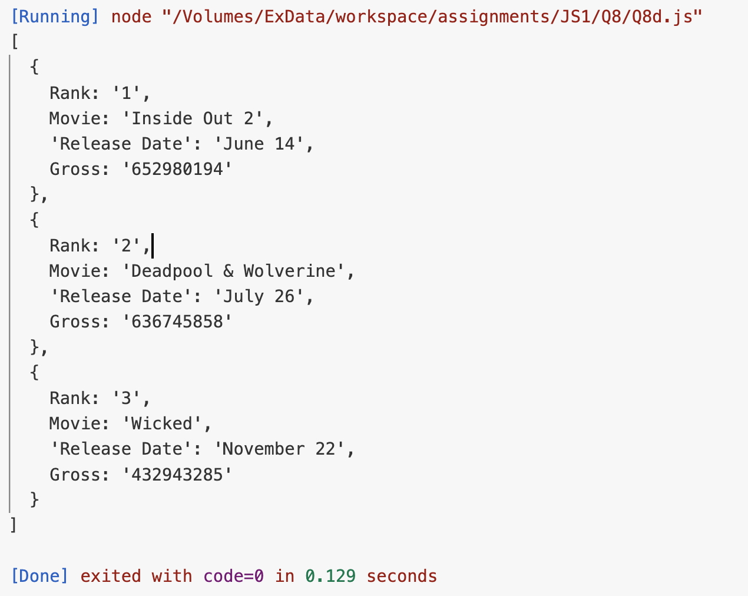

Q9. Working with String (string search)
Given the following text:
Peter Piper picked a peck of pickled peppers. A peck of pickled peppers Peter Piper picked. If Peter Piper picked a peck of pickled peppers, where’s the peck of pickled peppers Peter Piper picked?
Write a JavaScript code to search the number of times a string occurs. You can use indexOf function. IndexOf can be apply to a string. It takes 2 input parameters. The first parameter is your search key. The second parameter is the index in the string to start. For example, we want to search for the index of “man” start from the beginning of the string:
“1 man and 1 woman”.indexOf(“man”, 0);
The return value is 2 where “man” occurs.
Run | Return value
“1 man and 1 woman”.indexOf(“man, 0) | 2
“1 man and 1 woman”.indexOf(“1”, 0) | 0
“1 man and 1 woman”.indexOf(“1”, 1) | 10

Q10. JS in HTML & running in browser
You can run your JavaScript on a browser. Create a Q10.html file. You can use <input> tag with type of “button”. You don’t need <form> because you are not submitting a “form” for backend to process it. You can add event listener for this button with attribute onclick (i.e. user click the button).
<input type=”button” onclick=”RunJS()” …

Next, define your JavaScript in between <script> tag.
<script>
Function RunJS(){
…
</script>

<script> can be placed in <body>. Create RunJS function to output “Hello World” to console. You will learn how to create output to your browser in the next chapter. You need to know about DOM.
To test your code, open the html file using browser.
- Right click on browser and click on “Inspect” (on chrome).
- Click console tab.
- Click on the button to see your message.

